How to upload your code and complete challenges
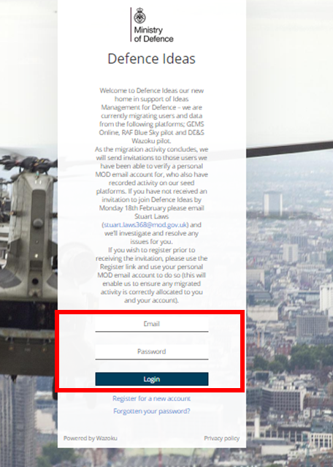

Login into the idea space using your MOD email address (mod.gov.uk) and create your own password - https://def-ideas.wazoku.com/#/login

Once logged in you can search for ‘jHub Coding Scheme’ and select the appropriate Challenge space (by default, the search includes people, ideas etc so it may be easier to select only Challenges)

Once within the Challenge space for your chosen module, information about the module can be found on the right-hand side of the page.
To submit against the challenge, click the Add Idea button at the top left or below the module description.
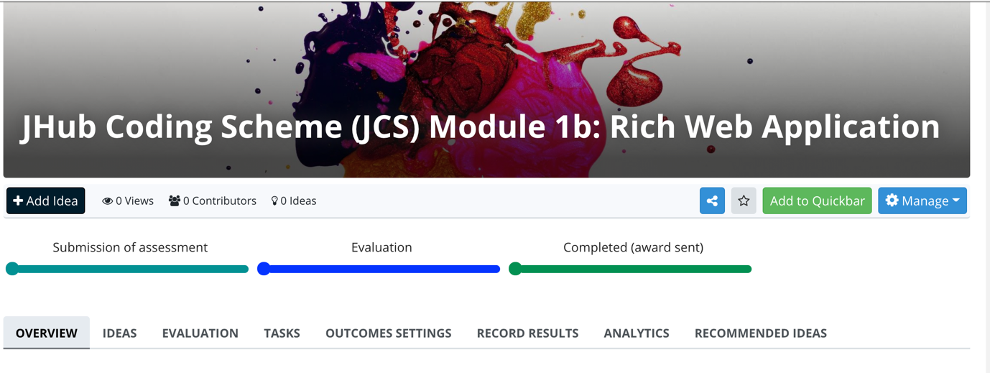
Once you have clicked on the ‘Add Idea’ button you can upload your course certificate of completion and plagiarism declaration to the idea space as well as any other supporting documents or links.

For Module 1b, screenshots of the application working with a few examples of different user input would be beneficial. These can be uploaded as image files, or combined into a MS Word or PDF file. Some users have chosen to record videos, but this is not mandatory!

Source Code Submission
The challenge requires your source code be submitted. Two ways of achieving this are: by sharing a link to a GitHub repo, or a link to a Stackblitz submission.

Stackblitz integration
You may wish to include integration with a service such as Stackblitz which will run your code without requiring a full IDE. This is not mandatory, but can be useful! It links directly with GitHub for projects that are already hosted there. This is similar to CodePen.io from Module 1a.
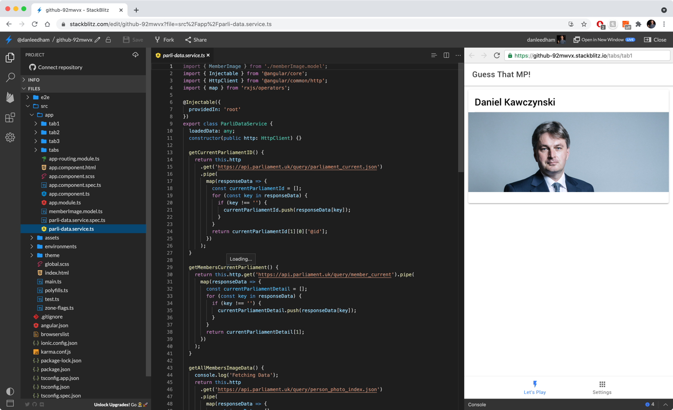

A Github Repo
Most applications should come ‘git ready’ if you’ve started them using the CLI, thus uploading to GitHub should be easy (they probably have a .gitignore file in your project that manages which files to synchronise and which not to).
To upload to GitHub, you can use either the CLI or choose to use the GitHub website or Application. For example: https://docs.github.com/en/github/importing-your-projects-to-github/adding-an-existing-project-to-github-using-the-command-line
Please do not upload the dependencies folder (such as node_modules) and instead ensure that the project can be built using a package manager such as NPM (this may appear as package.json).
If you choose to keep your submission as a private repo, a marker will request their account be given access to the code so they can build / mark it.
